# Practice Exercise 4

(Total Marks: 100%, 4%)

**Part#1**

Using Tables

Instructions: In this exercise, you will use your text editor to create a table and apply table styles. First, you insert a table element. Next, you add a table caption, table rows, table headers, and table data. Then, you create style rules to format the table. Work with the apply08.html file in the apply folder and the applystyles08.css file in the apply\css folder from the Data Files for Students. The completed webpage is shown in Figure 8–60. You will also use professional web development practices to indent, space, comment, and validate your code.

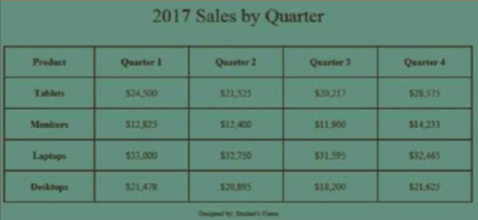

Figure 8-60

Perform the following tasks:

1. Open apply08.html in your text editor, review the page, add a title, modify the comment at the top of the page to include your name and today’s date, and replace “Student’s Name” with your name in the footer element.

2. Open the applystyles08.css file from the apply\css folder. Modify the comment at the top of the style sheet to include your name and today’s date.

3. In the apply08.html file, add a table element within the main element.

4. In the apply08.html file, add the following caption to the table element:

<caption>2017 Sales by Quarter</caption>

5. In the apply08.html file, add the following elements within the table element:

<tr>

<th>Product</th>

<th>Quarter 1</th>

<th>Quarter 2</th>

<th>Quarter 3</th>

<th>Quarter 4</th>

</tr>

<tr>

<th>Tablets</th>

<td>&#36;24,500</td>

<td>&#36;21,525</td>

<td>&#36;20,217</td>

<td>&#36;28,575</td>

</tr>

<tr>

<th>Monitors</th>

<td>&#36;12,825</td>

<td>&#36;12,400</td>

<td>&#36;11,900</td>

<td>&#36;14,233</td>

</tr>

<tr>

<th>Laptops</th>

<td>&#36;33,000</td>

<td>&#36;32,750</td>

<td>&#36;31,595</td>

<td>&#36;32,465</td>

</tr>

<tr>

<th>Desktops</th>

<td>&#36;21,478</td>

<td>&#36;20,895</td>

<td>&#36;18,200</td>

<td>&#36;21,625</td>

</tr>

6. In the applystyles08.css file, create the following style rules:

table {

width: 80%; margin-left: auto; margin-right: auto;

}

table, tr, th, td {

border-collapse: collapse;

border: solid 0.1em #000000;

padding: 1em;

}

td {

text-align: center;

}

caption {

font-size: 2em;

padding: 1em;

margin-top: 1em;

}

7. Add appropriate comments above each style rule.

8. Save all of your changes and open the apply08.html in your browser.

9. Validate your HTML document using the W3C validator found at validator.w3.org and fix any errors that are identified.

10. Validate your CSS file using the W3C validator found at http://jigsaw.w3.org/css-validator/ and fix any errors that are identified.

11. Submit the files in a format specified by your instructor.

**Part#2**

Adding Audio to a Webpage

Instructions: In this exercise, you will use your text editor to add audio to a webpage. Insert an audio element and three source elements. Work with the apply09.html file in the apply folder and audio files in the apply\media folder from the Data Files for Students. The completed webpage is shown in Figure 9–25. You will also use professional web development practices to indent, space, comment, and validate your code.

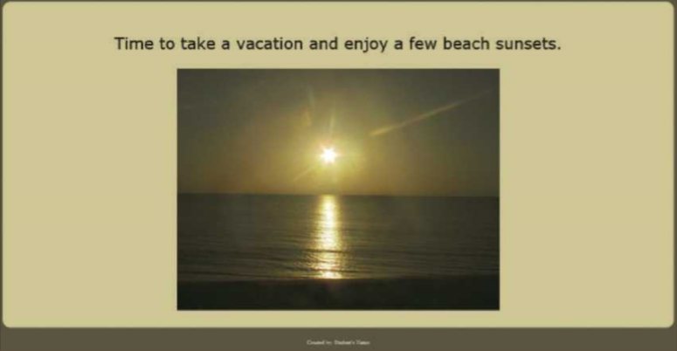

Figure 9-25

Perform the following tasks:

1. Open apply09.html in your text editor, review the page, add a title, modify the comment at the top of the page to include your name and today’s date, and replace “Student’s Name” with your name in the footer element.

2. Insert an audio element below the figure element.

3. Set the audio element to play automatically and to repeat continuously.

4. Insert three source elements within the audio element and use the three audio files contained within the apply\media folder.

5. Include a paragraph element within the audio element that advises legacy browser users that their browser does not support the audio element.

6. Save all of your changes and open the apply09.html in your browser.

7. Validate your HTML document using the W3C validator found at validator.w3.org and fix any errors that are identified.

8. Submit the files in a format specified by your instructor.

|  |  |
| --- | --- |
| **Practice Exercise 37** | **0.5%** |

* 1. Completed part#1 step 1-4

|  |  |
| --- | --- |
| **Practice Exercise 38** | **0.5%** |

1. Completed part#1 step 5-8

|  |  |
| --- | --- |
| **Practice Exercise 39** | **0.5%** |

1. Completed part#1 step 9-11

|  |  |
| --- | --- |
| **Practice Exercise 40** | **0.5%** |

1. Completed part#2 step 1-4

|  |  |
| --- | --- |
| **Practice Exercise 41** | **0.5%** |

1. Completed part#1 step 5-8